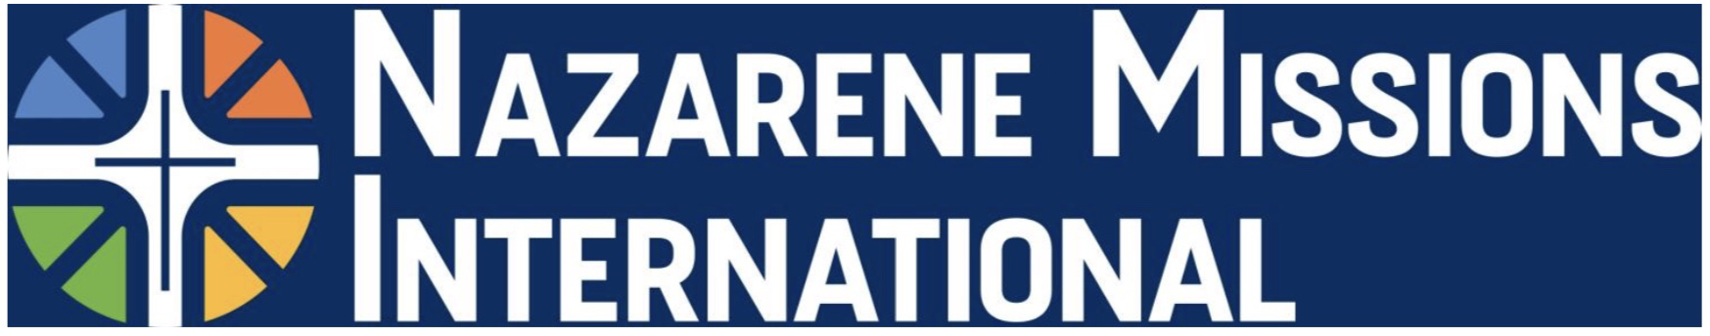
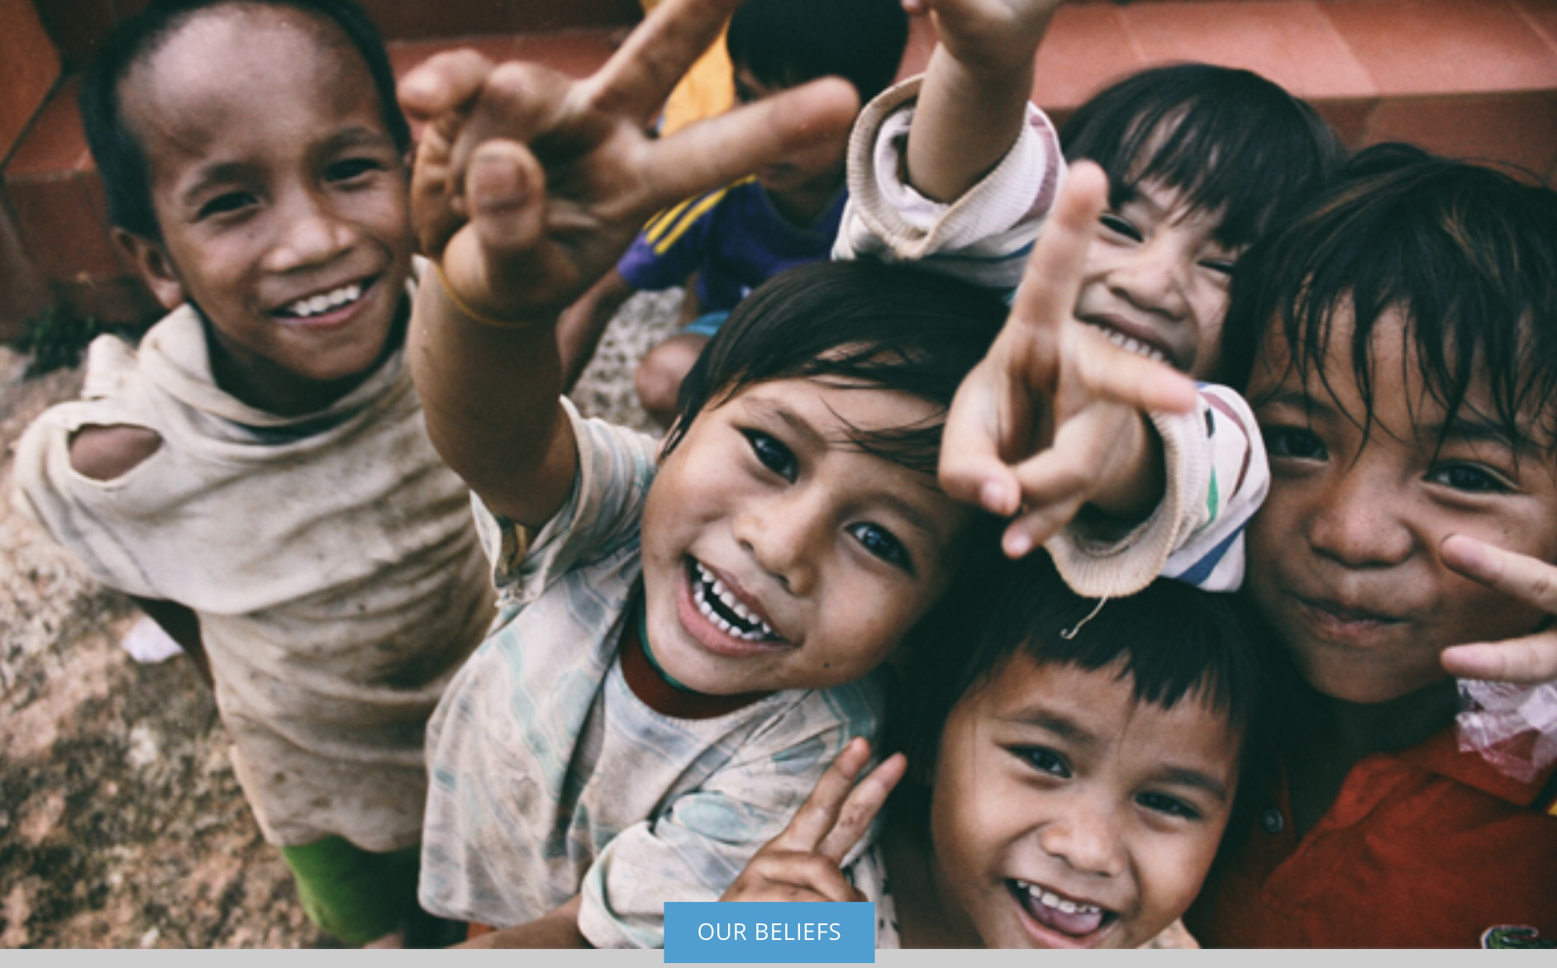
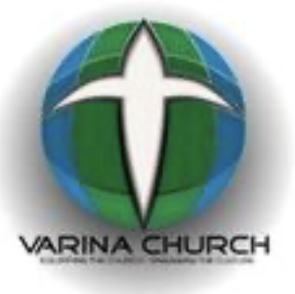
DON’T ASK “WHAT IS NMI” - BUT “WHO IS NMI”!

Varina Church NMI

Monthly News Letter #10 - August 2021
YOU – CHURCH OF THE NAZARENE - MAKING CHRISTLIKE DISCIPLES IN THE NATIONS
Click here to learn more about NMI
We are ONE PEOPLE –  PRAYING, GIVING, BUILDING, ENGAGING all AGES  to spread the GOOD NEWS of Salvation”  Faith Promise 2020/2021.  - Pledged: $18,530 Received: $6,629.10  Compassionate Ministry  - Crises Care Kits – Continues through October – our goal is 102 Thank you for your many donations. We delivered 12 kits to District Assembly and have many items left for more kits. But more items are needed to complete the kits. To ensure we get what is needed, you will soon receive SIGN UP information for specific items still needed. Your dedication and support will ensure we meet our goal for 102 kits. All items can be purchased at Dollar Tree and Family Dollar. Drop off BARREL - Church Lobby or 804-640-3252 for pickup.  - Child Sponsorship - CHILD SPONSORSHIP SUNDAY – TBD - Please Visit Child Sponsorship Link now and consider sponsoring a child today. Many of the kids, are older with special needs, and subject to human trafficking without our help.  Mission Education Study- MARK YOUR CALENDAR!  - Mission Study Adult and Teens – Please mark your calendar for Sunday August 29th. Will meet under pavilion – weather permitting. VOLUNTEER NEEDED  - Children’s Mission Study – 4th Sunday of each month – 10AM during Children’s Church.  Henrico Health & Rehab Ministry  - Restart was postponed to Fall – pending VOLUNTEERS who have received COVID Vaccine. Please see Cathy Pope if you are interested.  VOLUNTEERS NEEDED for all NMI Activities  COMING SOON – Fall Bike-a-thon, Fall Faith Promise Renewal, Crises Care Kits, Child Sponsorship, HHRC.  (804) 640-3252 Contact – Cathy Pope – THANK YOU! |  | NMI WEEKLY PRAYER MOBILIZATION EMAIL  A PRAYING CHURCH  Remember your missionaries throughout the year in prayer. Many are often facing troubled times in the places in which they serve. They need your support through intercession. The Prayer Mobilization Line (PML) is a weekly publication focusing on the prayer needs and praise reports for the global ministries of the Church of the Nazarene and our missionaries. Visit the above link to see past and current emails and to subscribe (free) to the weekly call to prayer.  Supporting our LINKS Missionary Shannon Smith SAFE RETURN TO CAMBODIA. Continue prayers for Shannon as she moves forward in her mission work. “Bicycles Bringing Hope to Cambodia” – the district goal was 400 bikes. Our VCN goal was 25 bikes – We DONATED 32 + bikes – Great JOB!! At district assembly the kids Bike-a-thon raised funds for another 38+ bikes – WAY TO GO KIDS! GRAND TOTAL together WE RAISED $22,675.90 to purchase 336 bikes. But WAIT - There’s MORE - funds are still coming in to help reach the goal of 400 bikes for the project. Oh, the joy that fills our hearts knowing how this will serve great purpose for the people in Cambodia through Shannon and her ministry. Follow Shannon on facebook and continue to hold her in your prayers. Thank you❤️  Shannons Facebook Page More about Shannon  VCN Online Giving - Select Bicycles for Cambodia  Bicycles Bringing Hope to Cambodia Video  MESSAGE FROM YOUR NMI PRESIDENT  ALL IN FOR JESUS!! Who’s With Me?  That is my Hope, no holding back, sitting silent to hear His command, His call, His Will.

